

**END SEMESTER ASSESSMENT (ESA) B.TECH(CSE)**

**IV SEMESTER**

**JANUARY – MAY 2025**

**DEPARTMENT OF COMPUTER SCIENCE & ENGINEERING**

**ELECTRONIC CITY CAMPUS,**

**BENGALURU – 560100, KARNATAKA, INDIA**

**UE23CS251B – MICROPROCESSOR AND COMPUTER ARCHITECTURE LABORATORY**

**PROJECT REPORT**

**ON**

Automatic Medicine Dispenser for Patients

SUBMITTED BY

**NAME SRN**

**Akilesh Gowda K S PES2UG23CS040**

**Akshay PES2UG23CS044**

**Amar PES2UG23CS052**

**ABSTRACT OF THE PROJECT:**

The Automatic Medicine Dispenser for Patients operates through an RFID-based authentication system, where a patient scans their RFID card to initiate the medication schedule. A Real-Time Clock (RTC) module tracks time and triggers medicine dispensing every 5 seconds via a servo motor-controlled mechanism. An ultrasonic sensor continuously monitors the medicine level in the container, alerting users via a buzzer if the level reaches zero. Once the medicine is dispensed into a bowl, an IR sensor observes whether the patient picks it up within 10 seconds. If the medicine remains uncollected, an alert is sent through a buzzer, ensuring patient compliance. A 16x2 LCD display provides real-time updates on system activities, including dispensing status, medicine level, and alerts.

This project integrates Arduino Uno as the central microcontroller, with multiple sensors and actuators working together to enhance automation, reduce human intervention, and improve medication adherence. The system is beneficial for elderly patients, individuals with memory impairments, or those requiring strict medication schedules, ultimately contributing to better healthcare management.

|  |  |  |  |  |  |
| --- | --- | --- | --- | --- | --- |
| |  | | --- | | **Device** |  |  | | --- | |  | | | **Use in the Project** | | --- |  |  | | --- | |  | |
| |  | | --- | | Arduino Uno |  |  | | --- | |  | | |  | | --- | | Acts as the **main microcontroller** to control all sensors and actuators. |  |  | | --- | |  | |
| |  | | --- | | RFID Module (with Tag) |  |  | | --- | |  | | |  | | --- | | Identifies the patient and **starts the medicine dispensing process**. |  |  | | --- | |  | |
| |  | | --- | | IR Sensor |  |  | | --- | |  | | |  | | --- | | Detects whether the **patient has picked up the dispensed medicine** within 10 seconds. If not, a buzzer alert is triggered. |  |  | | --- | |  | |
| |  | | --- | | Ultrasonic Sensor (HC-SR04) |  |  | | --- | |  | | |  | | --- | | Monitors the **medicine level** in the container and triggers a buzzer alert when low. |  |  | | --- | |  | |
| |  | | --- | | Real-Time Clock (RTC) Module |  |  | | --- | |  | | |  | | --- | | Keeps track of time for scheduled **medicine dispensing**. |  |  | | --- | |  | |

**CIRCUIT DIAGRAM:**

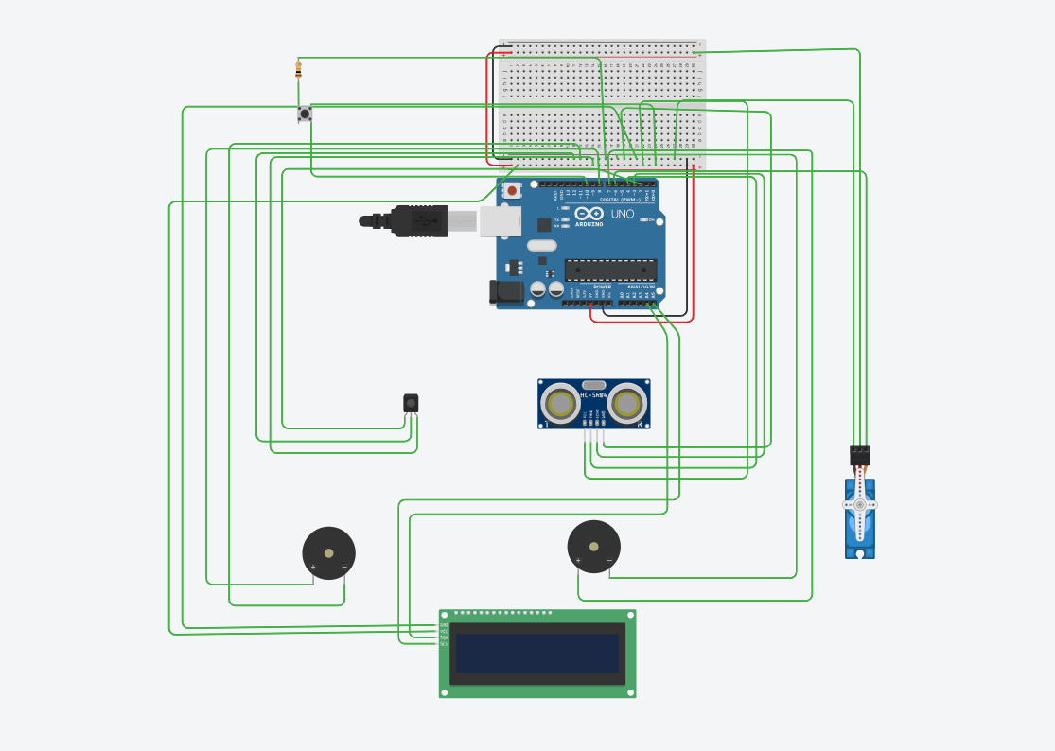

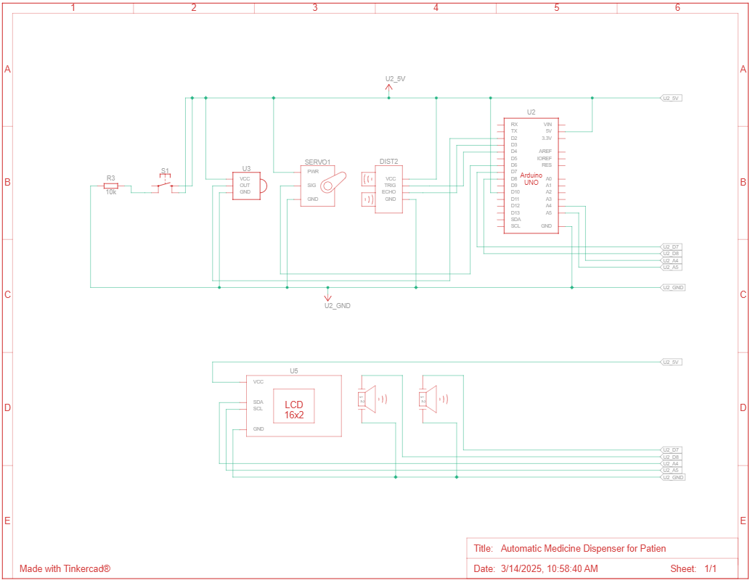

**Results and Testing of Automatic Medicine Dispenser :**

* **Medicine is dispensed at scheduled intervals** (every 5 seconds as per the demo).
* **Ultrasonic sensor detects the medicine level** and triggers a buzzer alert if the level is too low.
* **IR sensor detects if the medicine is picked up within 10 seconds**; if not, it triggers a buzzer alert.
* **Real-Time Clock (RTC) module tracks dispensing time** for patient adherence.
* **LCD displays system activities** (medicine dispensing status, low medicine warning, alerts, etc.).
* **Buzzer alerts notify caregivers** in case of missed medicine or empty container.

**Conclusion :**

* The **Automatic Medicine Dispenser** is an innovative solution designed to ensure **timely medication** for patients, reducing human errors and improving adherence. The system successfully automates the dispensing process using **RFID authentication, a real-time clock (RTC), and multiple sensors**.